Using this guide
This guide accompanies the National Treasury’s Strategic Procurement Framework (SPF) for Strategic Sourcing in the Public Sector. For more information, visit the National Treasury website at http://ocpo.treasury.gov.za/

PREPARE THE BUSINESS CASE AND OBTAIN APPROVAL

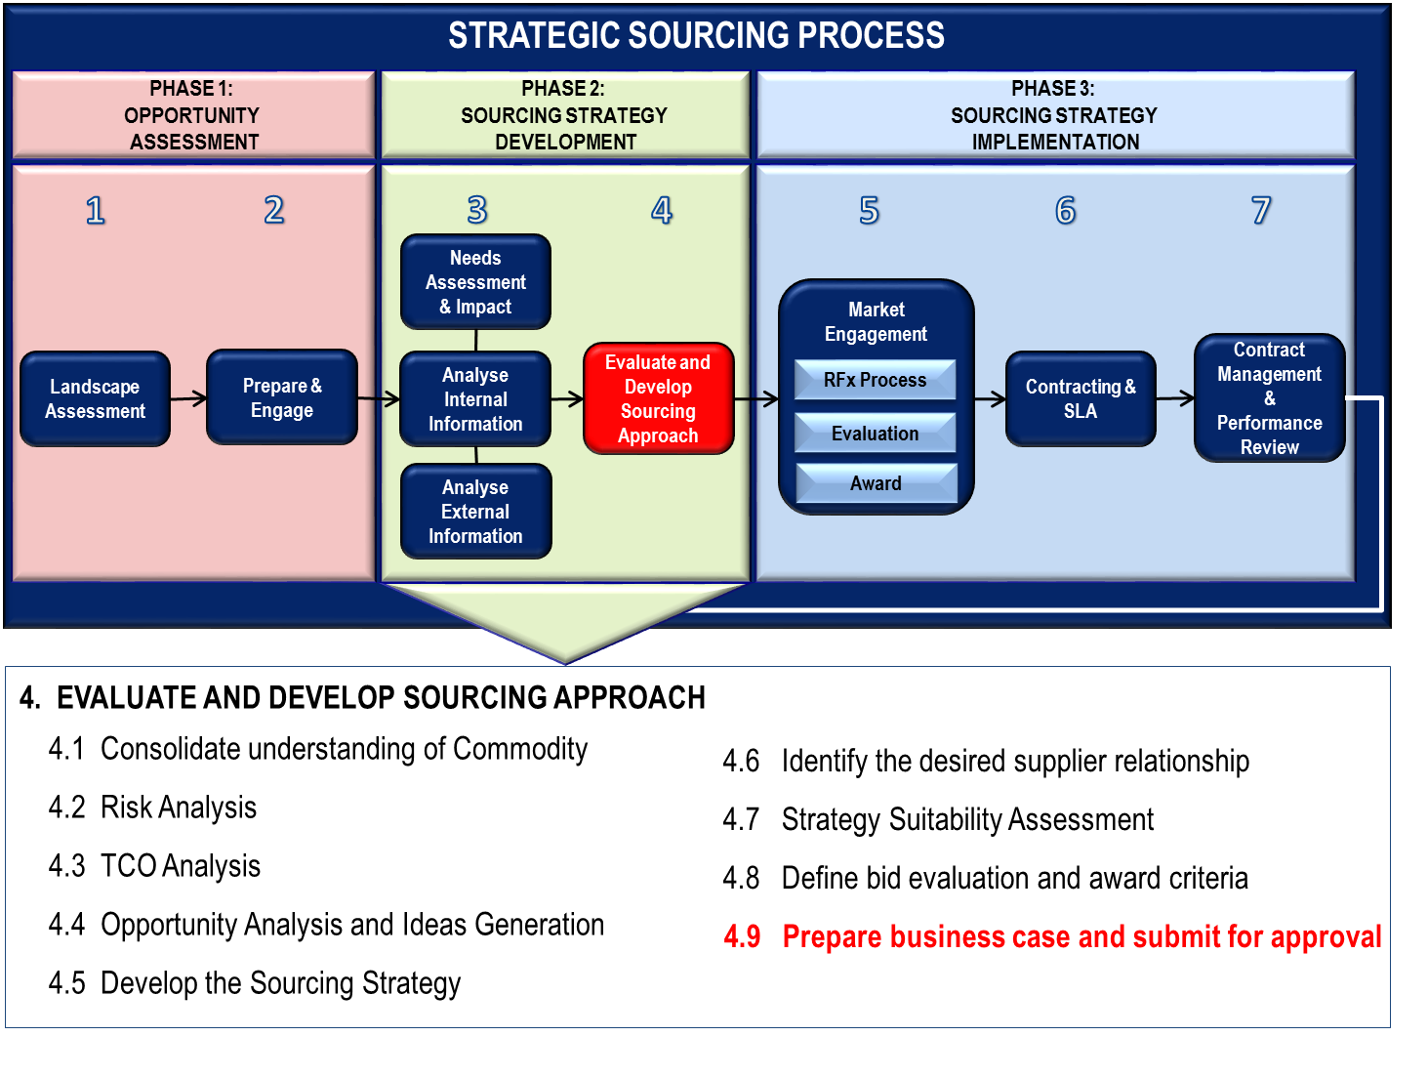
Preparing the Business Case and obtaining approval for continuation is the last activity of Stage 4 of the Sourcing Strategy Development phase that concludes the evaluation and development of the sourcing approach. The objective of this exercise is to document the information needed to enable a decision whether to support the proposed sourcing strategy before significant resources are committed and to obtain approval for proceeding with the implementation of the sourcing strategy.

CREATING THE SOURCING STRATEGY BUSINESS CASE
At this point you have done all the research work that is needed for your business case and have a very good understanding of how you want to proceed.
Prepare your business case in such a way that the reader understands the methodology and approach you took to get to your final recommendations.
You can prepare an “Outline / Template document” at the start of the project with the HEADINGS as set out in the methodology and fill in the blanks as you progress through the project. See Annexure A for the Business Case Structure. This will assist you in documenting the business case as you progress instead of trying to document everything at the end.
The Business Case is the one document that pulls together all the key elements from all the stages so far.
- This should contain a review of all the process evidence of stakeholder engagements, research, analysis findings, ideas generation, etc.
- A profile of the category with documented impacts and risks
- Recommended sourcing approach
- Evidence of alignment with procurement plan and strategic objectives.

What is a Business Case?
A business case documents the information needed to decide whether to support a proposed sourcing strategy before significant resources are committed to its development and implementation. It assesses the cost and benefits of proceeding with a project.
A business case assesses whether you need the procurement, the best way to conduct the procurement and how to achieve the best value-for-money outcomes.

Why do I need a Business Case?
A business case:
- provides an audit trail of your decision making process;
- documents the scope of factors impacting the sourcing strategy; and
- provides a template against which a sourcing strategy outcome can be monitored.

When do I need a business case?
Every sourcing strategy requires a business case, although the scope of the business case depends on the complexity of the procurement. For example:
- A simple , low risk, low value purchase may only need a description of the business need and price;
- A procurement activity with a clear business need, a well understood, competitive market and a standardised good or service may require a few paragraphs on a procurement approval template; and
- A highly complex procurement where the business need is less understood, with diverse levels of market capability and capacity, and varied options for goods and services, would need more in depth documentation to justify the need and to present a range of detailed implementation options.

OBTAIN APPROVAL FOR IMPLEMENTING THE BUSINESS CASE
The sourcing strategy options are documented in the Business Case and it is supported with factual information from the research and analysis that was done.
The Business Case must make recommendations as to how the market must be approached and which sourcing options would result in the best outcome. It must motivate and give evidence of estimated savings as well as operational process improvements.
During Stage 2 you have done a stakeholder map and established a governance structure at which the business case must be presented for approval. It may have to go through various approval processes, e.g.:
- Cross Functional Sourcing Team – to have a final look at their work and ensure that everybody agrees with the recommendations
- Bid Specification Committee – to ensure that the CFST recommendations are sound and that it can be recommended to the BAC for continuation.
- BAC and AO/AA – The final approval of the strategy and proposed market approach vests with the BAC and AO/AA.
The departmental internal governance structures will determine the approval process that has to be followed.

ANNEXURE A
BUSINESS CASE STRUCTURE
The following table lists a range of factors that may be relevant in preparing the Business Case to justify going to the market, allocating resources and committing funds. Not all factors are relevant in all cases as it depends on the complexity of your procurement activity.
Contents | Complexity of procurement
 | Routine | Leverage | Bottleneck | Strategic
Executive Summary
- Brief introduction/background/requirement
- Problem Statement
- Preferred option
- Assumptions and constraints
- High level analysis of proposal
- Market engagement strategy
- Estimated value of the contract
- Estimated period of the contract
- Estimated savings
- Project Ownership
Strategic Context
- Project background
- Project Objectives
- Business Need
- Key benefits
- Department strategy alignment
- Government policy objective alignment
- Output/outcome success factors
PHASE 1: OPPORTUNITY ASSESSMENT
Stage 1: Landscape Assessment
- Portfolio analysis, commodity positioning & prioritisation
- Commodity group/category classification
- Project Proposal and Approval

Stage 2: Prepare & Engage
- Cross-functional Project Team
- Stakeholder Analysis
- Governance Structure
- Communication Plan
- Project scope
- Project Plan & Charter

PHASE 2: SOURCING STRATEGY DEVELOPMENT
Stage 3: Information Gathering
Stage 3.1: Needs assessment and Impact
- Preparing for Stakeholder engagements
- Identify business needs & requirements
- Obtain & Review existing sourcing plans & contracts
- Collect, document and review technical specifications
Stage 3.2: Internal Information Analysis
- Spend analysis
- Demand Planning
- Price & Cost Analysis
- Value Chain Analysis
Stage 3.3: External Information Analysis
- Supply Chain Analysis
- Supply Market Analysis
- Supplier Differentiation Assessment
- Identify Potential Suppliers
Stage 4: Evaluate and develop the Sourcing Approach
- Risk Analysis
- TCO Analysis
- Opportunity Analysis & Idea Generation
- Develop the Sourcing Strategy
- Desired supplier relationship
- Strategy Suitability Assessment
- Bid evaluation and award criteria

PHASE 3: SOURCING STRATEGY IMPLEMENTATION
Stage 5: Market Engagement, Evaluate & Award
- Market approach plan
- Evaluation methodology
- RFx method
- The Offer Structure (Bid Document Structure)
- Market approach process and timelines
- Bid Evaluation, Negotiation and Award Process &timelines
Stage 6: Contracting and Service Level Agreement
- Transition plan to new contract
- Key Performance Indicators (KPI's)
- Draft SLA
Stage 7: Contract Management & Performance Review
- Contract management & Administration
- Performance monitoring
- Benefits tracking
- Continuous improvement strategy
CLOSURE
Recommendations and Approvals
- Outcome and Output objectives
- Recommendations
- Approval process

